

School of Computer Science and Artificial Intelligence

Program: B. Tech (CSE)
Specialization: AIML
Course Title: CLOUD COMPUTING
Name of Student: V.BHARATH
H. No: 2403A52207
Batch No: 09
Academic Session: 2025-2026

Assignment-18
Topic: “From Virtual Machines to Containers: The Docker Revolution” Objective:
Understand why Docker containers are replacing traditional virtual machines by containerizing your existing chat application and comparing deployment approaches.
Task 1: Traditional VM Deployment - Deploy on EC2 the "Old Way" # Connect to your EC2 instance and run: aws s3 cp s3://chat-app-yourname/app.js .
aws s3 cp s3://chat-app-yourname/index.html . aws s3 cp s3://chat-app-yourname/package.json .
# Install Node.js manually sudo apt update
sudo apt install nodejs npm -y # Install dependencies and run npm install node app.js
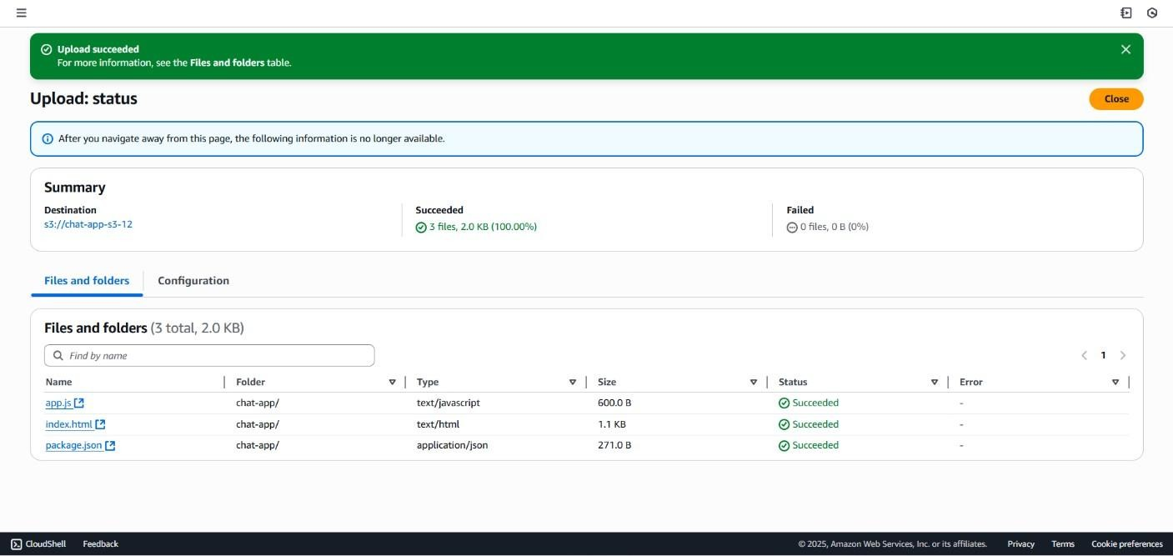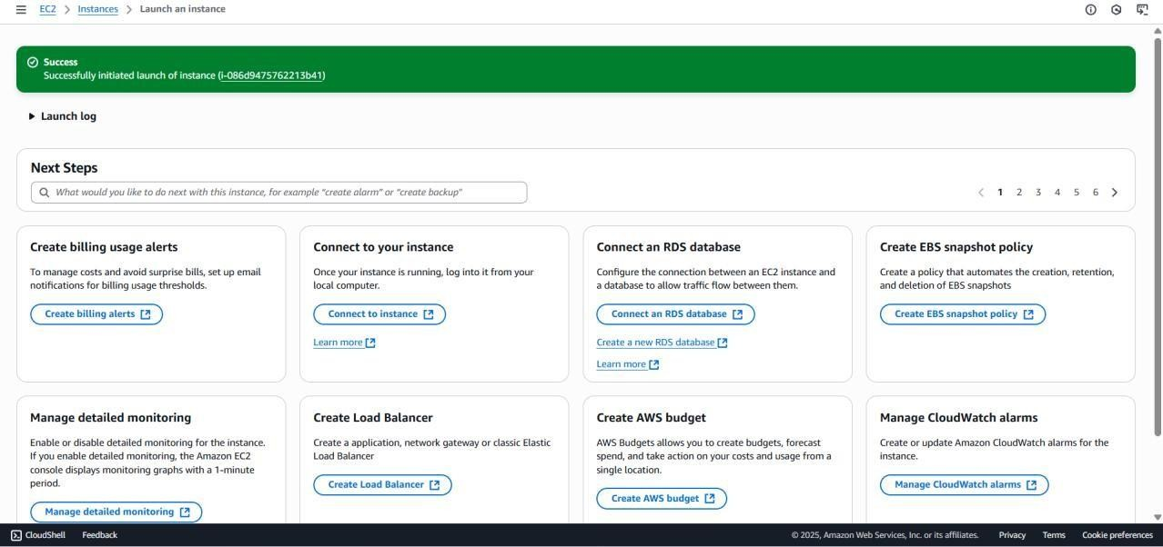

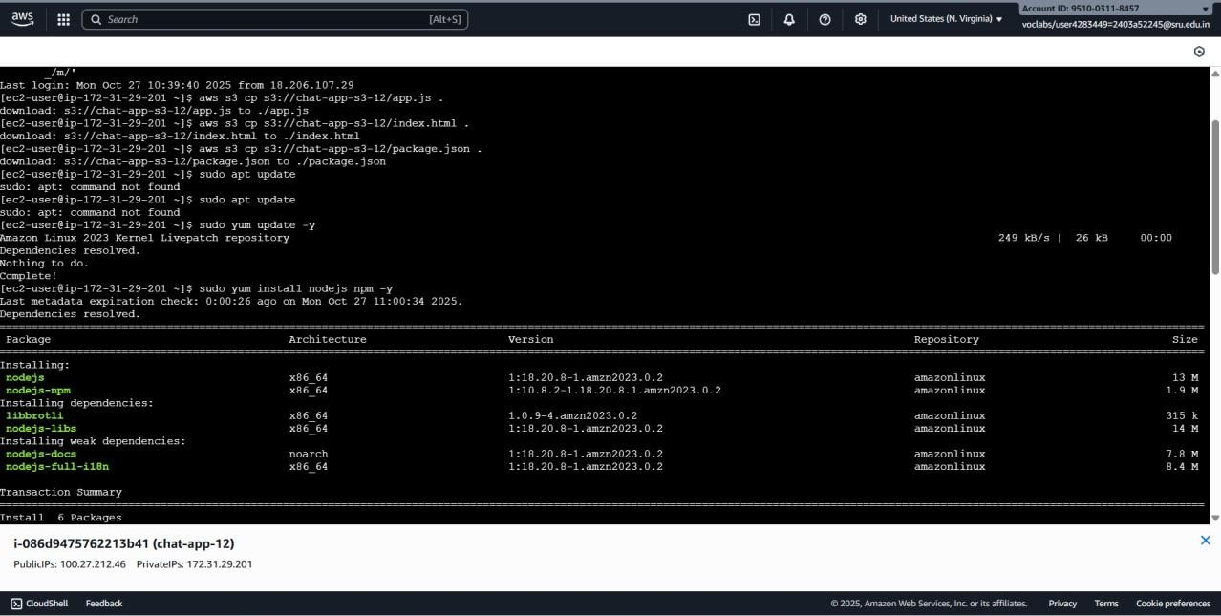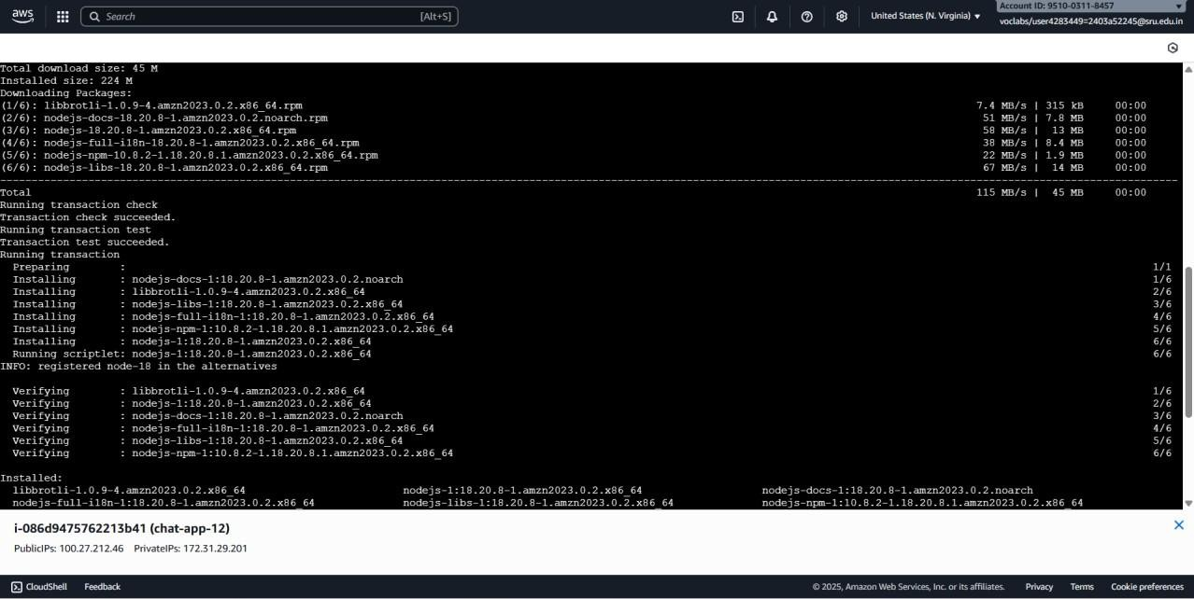
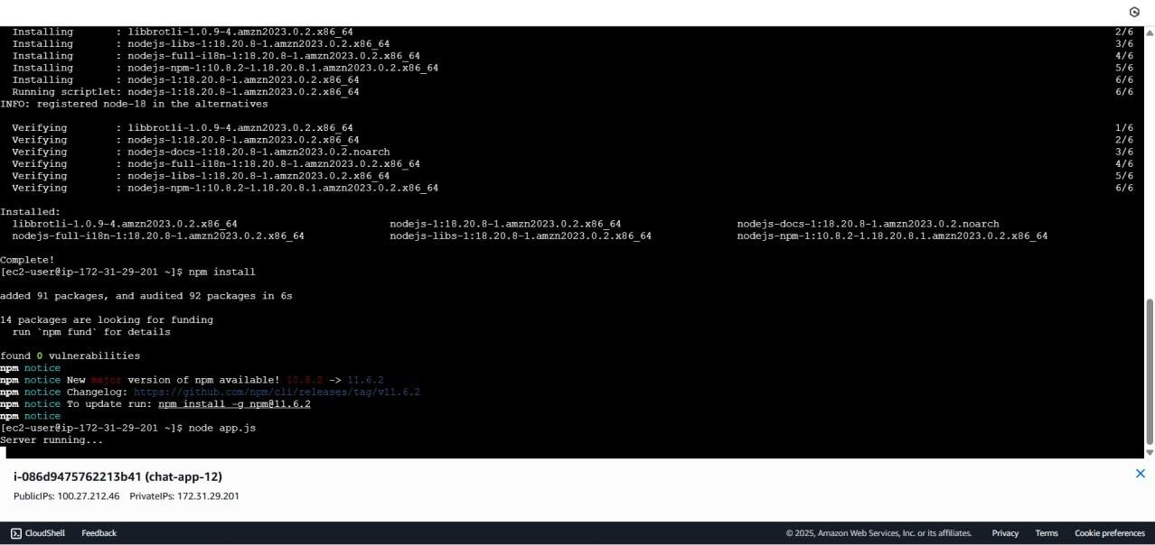

Task 2: Containerize with Docker –
Use Play with Docker (PWD)
- Go to: https://labs.play-with-docker.com/
- Sign in with Docker Hub account 3. Click "Add New Instance" Create/Upload Docker Files:

First, create folder: >mkdir chat-app
>cd chat-app


Then upload three files of chat-app using drag -drop operation
Next, >mkdir Dockerfile

Click on EDITOR
Then select Dockerfile, in editor space – copy, paste the below:
FROM node:18-alpine
WORKDIR /app
COPY package*.json ./ RUN npm install COPY
. .
EXPOSE 3000
CMD ["node", "app.js"]
Save the code – close the tab.
Coming back to Play with Docker:
Build and Run:
> docker build -t my-chat-app . (dot)
> docker run -d -p 3000:3000 my-chat-app
Output: chat app running in PWD at port 3000
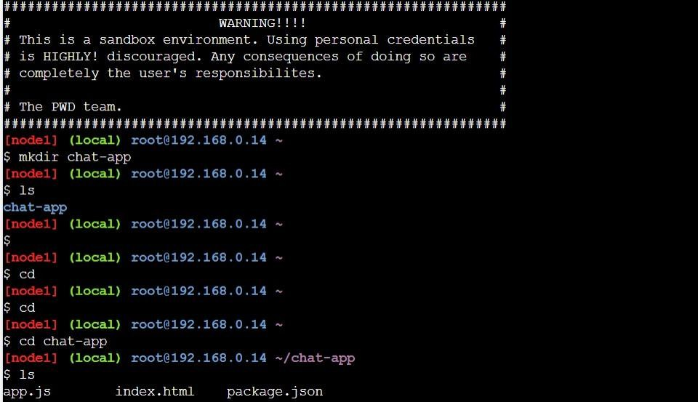
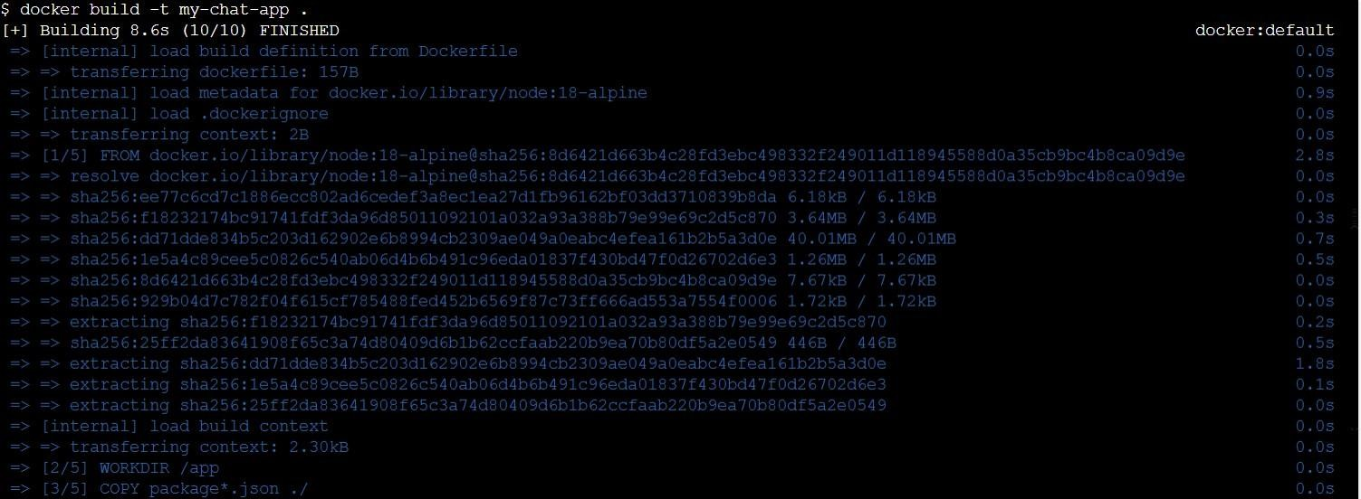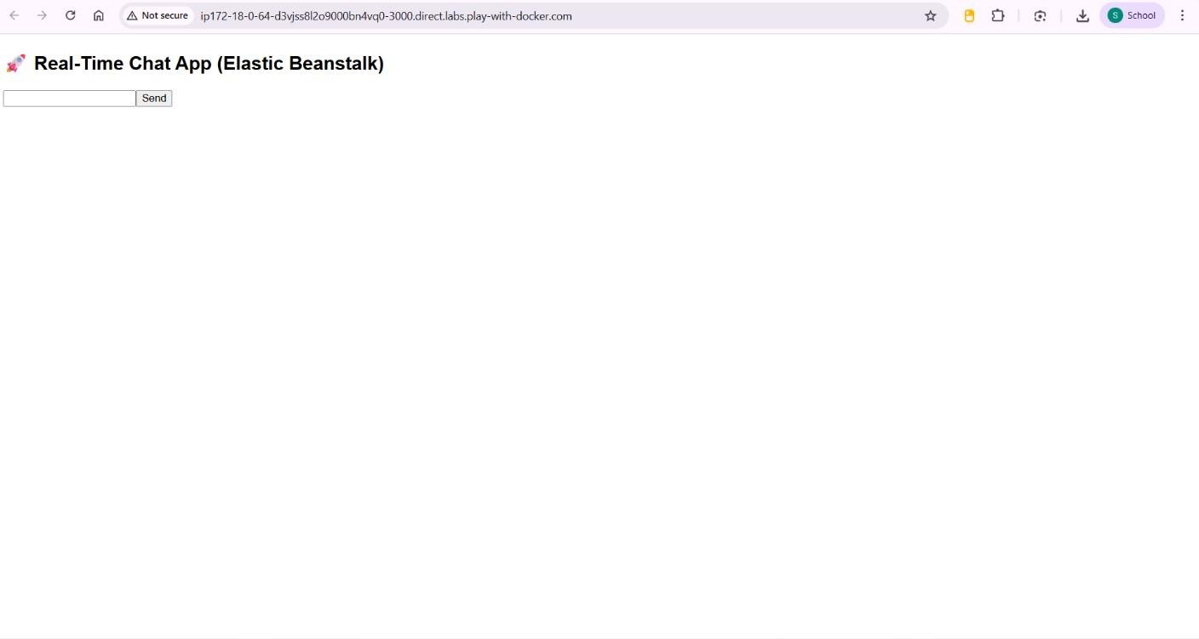

Task 3: Uploading the chat app image to Docker hub so that anyone can run your app.
>docker login
> docker tag my-chat-app <your-docker-hub-username>/chatappyourname:v1
>docker push <your-docker-hub-username>/chat-appyourname:v1
